Coastal Landforms and Processes

GEOL1551

NAME: ________________________

A very large portion of the total human population (approx. 40%) lives within 100 km of the coast. An even larger portion depends on the coasts for economic prosperity. The coasts are also home to many plants and animals that are very important from a biodiversity standpoint and maintain the health of adjacent terrestrial (upland) and marine communities. However, coastal regions are under threat by changing climate and rising sea-level, as well as adverse impacts of humans (overfishing, chemical pollutants, nutrient run-off, excessive sediment input, etc.). This exercise is designed to enhance your understanding of the coastal environments and processes, and the rapid changes that are occurring.

Requirements: Google Earth Pro (downloaded)

Sea-level Rise and Shoreline Change

The coast is constantly changing as sea-level changes. 20,000 years ago, sea level was 120 meters lower than today because water from the oceans was locked up in the ice sheets that covered much of North America and Asia during the last glacial period. As the ice-sheets melted between 20,000 and 8,000 years ago, sea-level rose very rapidly as the water returned to the oceans, and the shoreline moved very quickly. Similar rates of rapid rise and shoreline retreat are possible in the near future if Greenland and West Antarctic Ice Sheet melting continue to accelerate.

1. Open Google Earth and zoom into the North Carolina coastal region (should look like the image below).
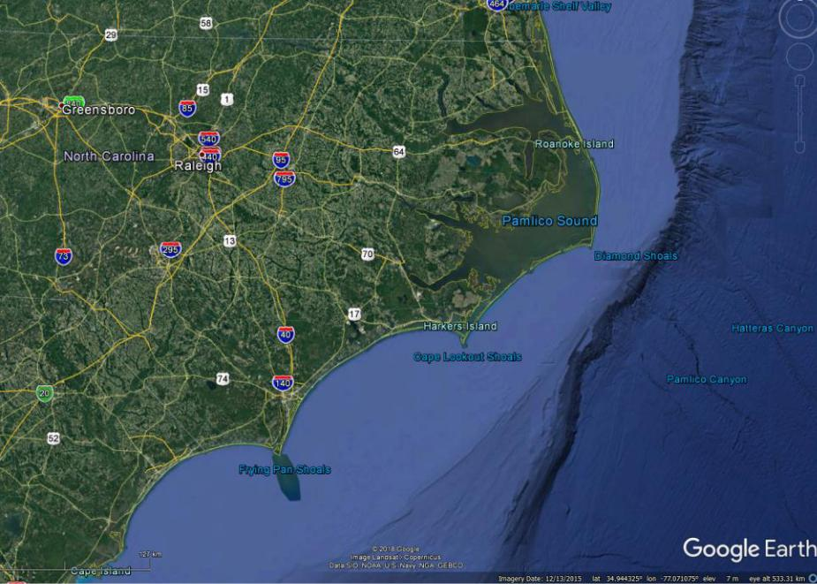

With your curser, pan along the edge of the continental shelf to find where -120 m is (you can see the

Elevation in the lower right corner of the Google Earth page). Use the Path function at the top left side of the page to digitize a line that marks the edge of the glacial shoreline (at -120 m below modern sea level) extending from the northern border of NC with VA to the southern border of NC with SC.

Note that when you select the Path function, it gives you options to change the “Style, Color” and width of your line. Make it yellow, with a width of “2.0”. Name this path the “glacial shoreline”. Take a screenshot, save it, and submit with your lab.

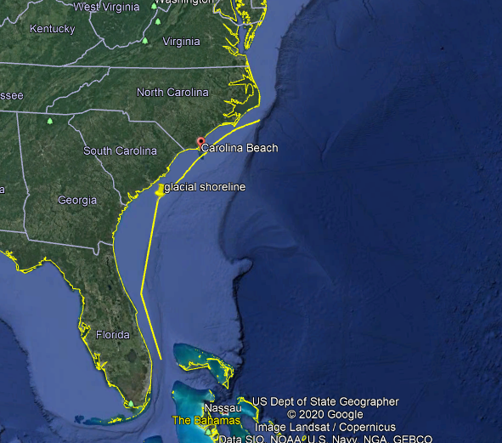

- Using the measuring tool at the top of the page measure the distance from the present shoreline to the glacial shoreline you just drew at the NC/VA border, the NC/SC border, and Cape Hatteras. Enter the distances below:

NC/VA shoreline to the glacial shoreline ___320____km, __198.84_______miles

Cape Hatteras to the glacial shoreline __500________km, __310.7_________miles

NC/SC shoreline to the glacial shoreline _____560______km, ___348_______miles

- The glacial shoreline represents sea-level at 20,000 years ago, and the modern shoreline became occupied around 8,000 years ago when sea-level reached its modern elevation. Using the maximum distance above (should be the NC/SC border), calculate the following (SHOW YOUR WORK):

- Average rate of shoreline erosion (landward/horizontal movement of shoreline) during the de-glaciation from 20,000 to 8,000 years ago in meters/year (m/y).

Average rate of shoreline = meters / year = $\frac{560,000}{20,000-8,000}$ = 46.67 m/y

- Average rate of sea-level rise (vertical change) from 20,000 to 8,000 years ago in millimeters/year (mm/y).

Average rate of shoreline = meters / year = $\frac{560,000,000}{20,000-8,000}$ = 46666.67 m/y

Recent Changes

Now zoom in on the Chincoteague Island region of Virginia (approx. 37.865°N; 75.380°W; along the Delmarva Peninsula - see the image below).
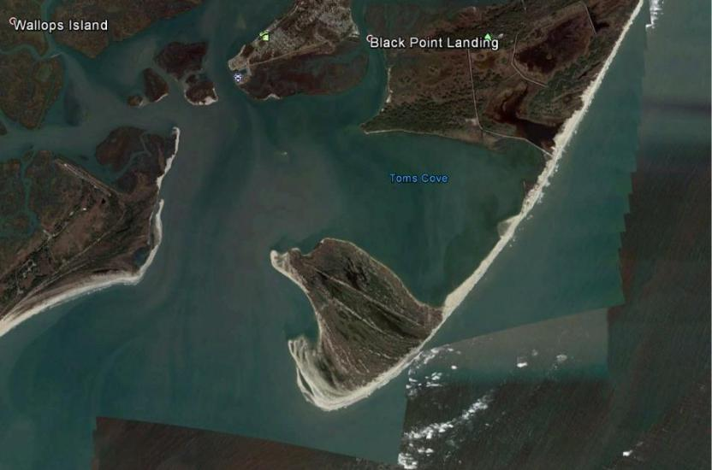

Use the Historic Imagery viewer at the top

Of the page to assess changes to this shoreline between 1984 and 2016. The best way to do this is to slide the historic photos bar to the far left (12/1984), then use the Path function to quickly digitize the shoreline (again, make the line yellow to stand out). Then, slide the historic photos bar to the far right (11/2016) and compare the modern photo to the past shoreline position that you digitized.

- Take a screenshot of your image with the 11/2016 shoreline image and the digitized yellow trace of the shoreline from 1984. Save and include in submission.

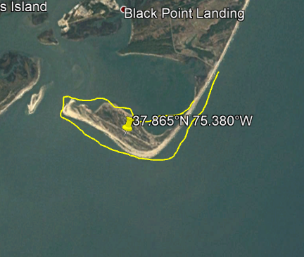

Historic photos bar (12/1984)

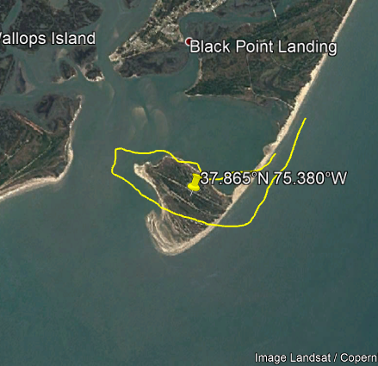

Historic photos bar (11/2016)

- Given the changes in the coastline from 1984 to 2016, what is the direction of long shore transport here?

The shape of the coastal line changed immensely since 1984 to 2016.
In 1984, there was a longer and slender coastal line which changed to a shorter and thick coastal line by 2016.
The direction of the long shore transport also changed, in the years of 1984, it was towards the East while by 2016 it was changing and going towards the South.
What can be observed in the two figures is that perhaps there has been great coastal erosion in this region

Coastal Landforms and Morphology

Explore Bear Island, NC (34.633°N; 77.140°W). This is an undeveloped island that is part of Hammock’s Beach State Park. A ferry is provided from the mainland office near Swansboro, if you ever want to explore it on foot. Geologists from ECU are performing research here to understand hurricane impacts.

Use Google Earth and the labeled image below to indicate the type of geomorphic feature at each location.

Choose from the following list:

Over wash; dunes; maritime forest; spit; flood-tide delta; ebb-tide delta; salt-marsh; inlet channel
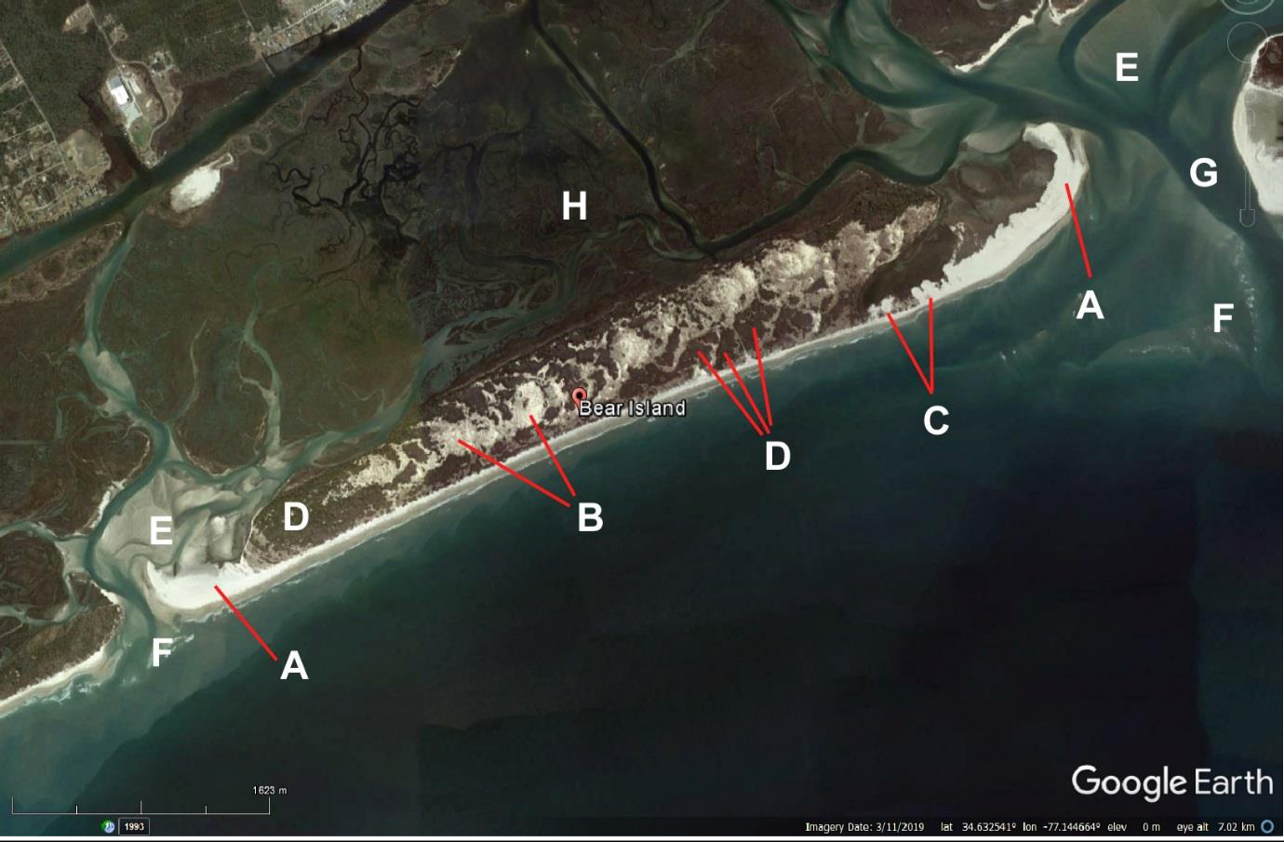

6-13

- Over wash E. flood-tide delta

- salt-marsh F. ebb-tide delta

C. spit G. inlet channel

D. Ocean dunes Maritime forest.

MARINE POLLUTION

Human beings now have the technology to impact every region on Earth and even the farthest reaches of the oceans are feeling the effects. In this lab you will investigate the extent of just two forms of human pollution – plastics and oil – in the sea. The following websites contain vast amounts of data. Read the indicated sections carefully and study the diagrams in detail to answer the questions. For the Plastics website, the panel to the left shows the order in which topics are addressed on the website. Questions below are designated according to these section headings. You can click on the topic to the left to go to the part of the website where you will find information to answer the questions.

Plastic Pollution in the Sea

To understand the extent of plastics pollution on the marine environment, you will first read about plastic production and waste management. Then you will study the sources and distribution of plastic waste in Earth’s oceans. Most of the information to answer the questions is found on this website – Lab is divided by the section headers on the website: https://ourworldindata.org/plastic-pollution

I. Introductory Section

- In which year was the first synthetic plastic, Bakelite, produced? The year 1907

- The mass unit for plastics in this article is the “tonne”. What is the equivalent of a metric tonne in US pounds?

2,204.6 pounds

II. How much plastic enters the world’s oceans?

- Plastic waste most at risk of entering the oceans is generated in coastal populations (within 50 kilometers of the coastline). Using the figure in this section, what percent of global plastic waste (GPW) generated in 2010 originated in coastal regions? SHOW YOUR WORK!

Plastic waste generated in coastal regions is most at risk of entering the oceans; in 2010 coastal plastic waste – generated within 50 kilometers of the coastline – amounted to 99.5 million tonnes;
Global plastic waste was 275 million tonnes.

Percentage of plastic wastes from the coast = Plastic waste at coastal regions/ GPW* 100%
= $\frac{99.5}{275}$ *100% = 36.2%

III. How much plastic does the world produce?

4) How many years did it take for the world’s plastic production to increase from 2 million tonnes per year in?
1950 up to 300 million tonnes per year?

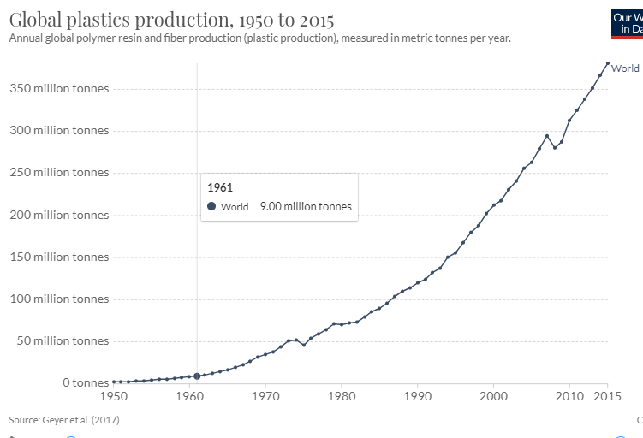

It is in the year 2010 that plastic produced hit 300 million tons per year hence
2010 – 1950 = 60 years

VI. Mismanaged plastic waste

- Consult the imaged labeled: Share of plastic waste that is inadequately managed, 2010 to answer these questions. You can hover over a country to see its value and over the scale bar at the bottom.

Inadequately disposed waste is not formally managed and includes disposal in dumps or open, uncontrolled landfills, where it is not fully contained. Inadequately managed waste has high risk of polluting rivers and oceans. This does not include 'littered' plastic waste, which is approximately 2% of total waste (including high-income countries).
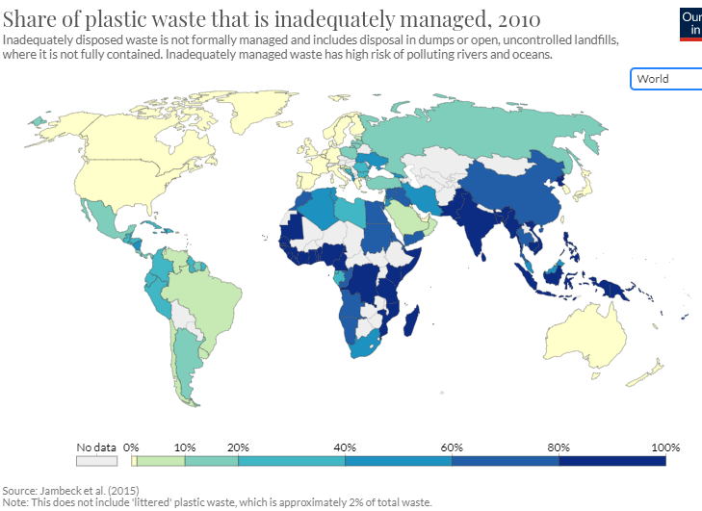

  - Name 2 countries that inadequately managed between 60% and 80% of their waste in 2010.

China
Egypt
Namibia

  - Name 2 countries that inadequately managed between 20% and 40% of their waste in 2010.

Libya
Gabon
Peru and Columbia.
- To answer the questions below consult the section entitled: “Share of plastic waste that is littered” and go to the image (Plastic waste littered, 2010) to see littered plastic from coastal populations (within 50 kilometers of a coastline).

Note that littered waste is distinct from ‘inadequately disposed’ waste in that it represents plastics that are dumped or disposed of without consent in an inappropriate location. While high-income countries tend to have effective waste management infrastructure and, therefore, very small quantities of inadequately disposed waste, they can contribute to plastics pollution by littering.
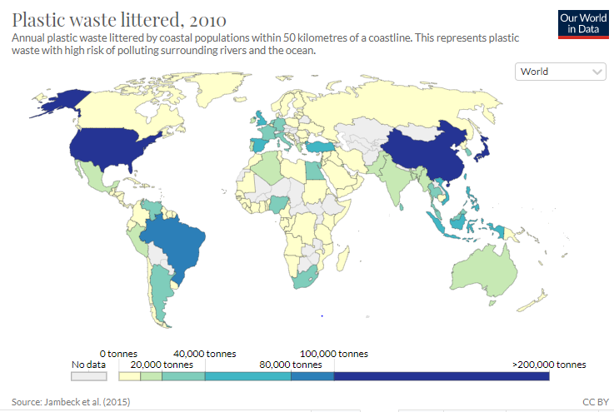

- List 2 countries that littered more than 100,000 tonnes of plastic waste in 2010.
United States of America
China

- List 2 countries that littered between 40,000 and 80,000 tonnes of plastic waste in 2010.
Egypt
South Africa.
Nigeria

VII. How much of ocean plastics come from land and marine sources?

At the global level, best estimates suggest that approximately 80 percent of ocean plastics come from land-based sources, and the remaining 20 percent from marine sources. There are multiple routes by which plastic can enter the ocean environment. One key input is through river systems. This can transport plastic waste from further inland to coastal areas where it can enter the ocean. As we see in the following charts, there is high concentration of plastic within river systems geographically. The top 20 polluting rivers accounted for more than two-thirds (67 percent) of the global annual river input.

- Name three common sources of marine-based plastic pollution.
Land based plastic wastes from urban and storm runoff.
From overflow of sewers.
From beach visitors
Illegal dumping.

VIII. Which oceans have the most plastic waste?

- In 2013 how many tonnes of plastic waste were floating at the ocean surface in the North Pacific Ocean?

About 21,290 metric tons of plastic waste were floating at the ocean surface in the North Pacific Ocean in the year 2013

- Consult the graph entitled, “Plastic mass and particles across the world’s surface oceans”. Click on the graph to enlarge it.

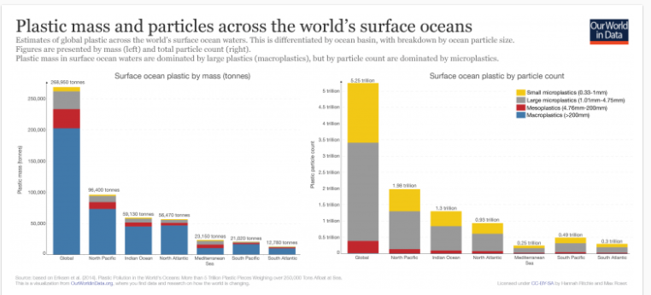

Of the total number of tonnes of plastic estimated to be adrift in the North Atlantic surface ocean, how many tonnes occurred as macro plastics?

50,000 tonnes

What percent of the total global surface-ocean plastic did this represent? SHOW YOUR WORK

Macro plastics in North Atlantic = 50,000 tonnes

Total global surface-ocean plastic = 268, 590 tonnes

% = $\frac{50,000}{268,590}$ * 100% = 18.62%

IX. Where does plastic accumulate in the ocean and what does that mean for the future?

- List two possible explanations as to why we find at least 100 times less plastic in our surface ocean waters than has been released in recent decades?

- One of the reasons why we had high plastic waste levels in the past decades was due to lack of awareness on how much it affects our marine systems. However, over the recent decades there has been a great number of public awareness on the effects of plastic wastes to our marine system and this has helped reduce the amount of plastic wastes being disposed by people.
- Laws and regulations have also been set on dumping of plastic wastes. This laws governs and protect our marine systems and anyone found going against this laws is found guilty and will be sentenced or fined. Such laws and regulations have helped reduced the level of plastic wastes being damped into our marine systems over the recent decades.

XI. How does plastic impact wildlife and human health?
- What are the three key pathways by which plastic debris can affect wildlife?

- Entanglement whereby plastic debris causes deaths of aquatic wildlife.
- Ingestion
- Interaction

